**Moulik Tammana**

**Q10. Try Inter VLAN routing with Router.**

**To enable communication between different VLANs in a network using a router, we implement Inter-VLAN Routing using a Router-on-a-Stick configuration. This setup involves creating sub-interfaces on a single router interface to handle multiple VLANs. First, configure VLANs on the switch and assign them to respective ports. Ensure that the switch port connected to the router is set as a trunk to allow traffic from multiple VLANs. On the router, access the corresponding GigabitEthernet or FastEthernet interface and create sub-interfaces for each VLAN. Each sub-interface must be assigned an IP address that acts as the default gateway for that VLAN and should be encapsulated with the respective VLAN ID using dot1Q encapsulation. After configuration, ensure that the end devices have correct default gateways matching their VLAN’s sub-interface IP. Finally, test connectivity by pinging devices across VLANs to verify that the router is properly forwarding traffic between VLANs.**

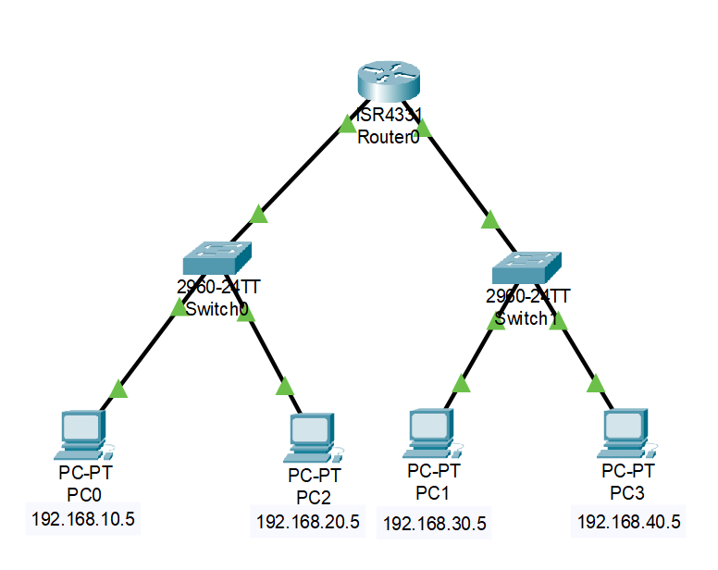

**Switch0:**

**VLAN 10: Fa0/1, Fa0/2 and Default Gateway: 192.168.10.1**

**VLAN 20: Fa0/3, Fa0/4 and Default Gateway: 192.168.20.1**

**Switch1:**

**VLAN 10: Fa0/1, Fa0/2 and Default Gateway: 192.168.30.1**

**VLAN 20: Fa0/3, Fa0/4 and Default Gateway: 192.168.40.1**

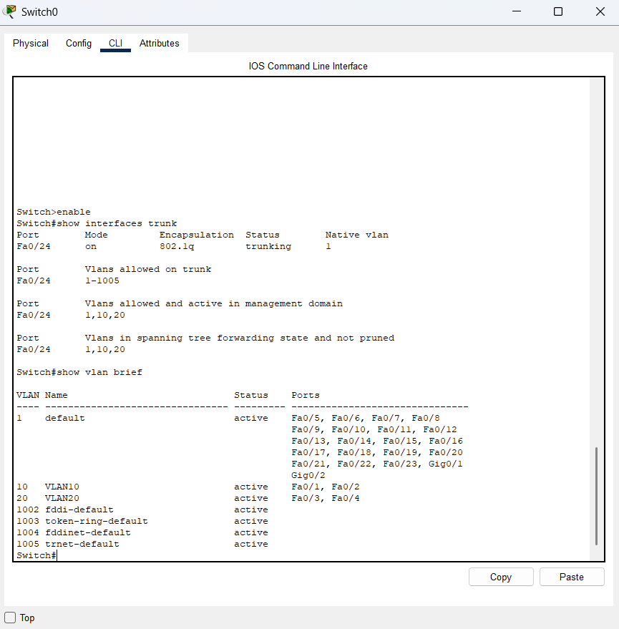 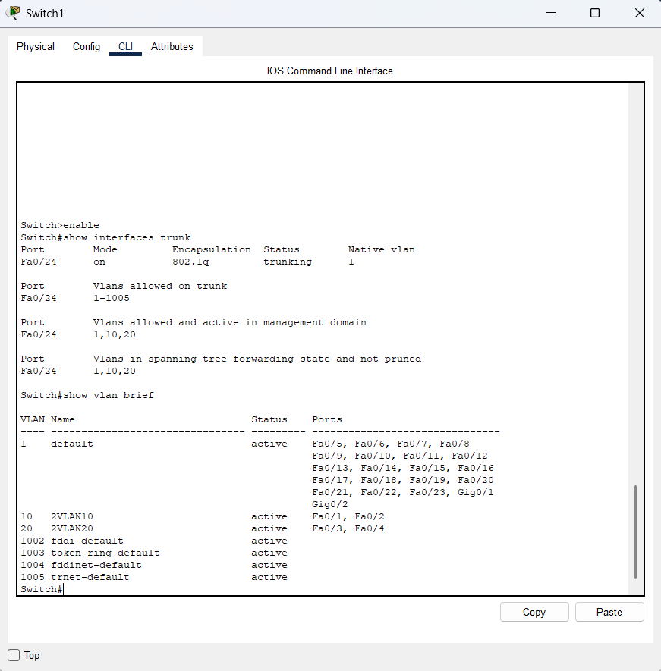

**Sub-interface configureation in the router:**

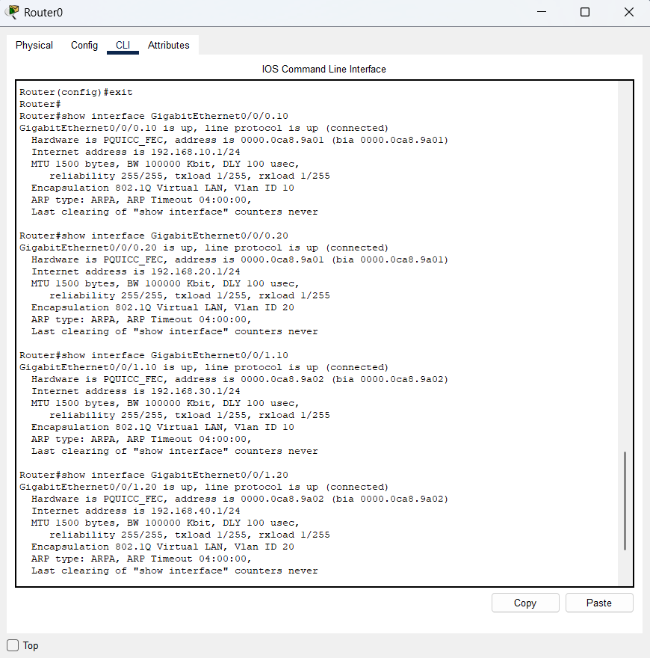

**We were successfully able to ping all the end PC in different VLAN connections.**

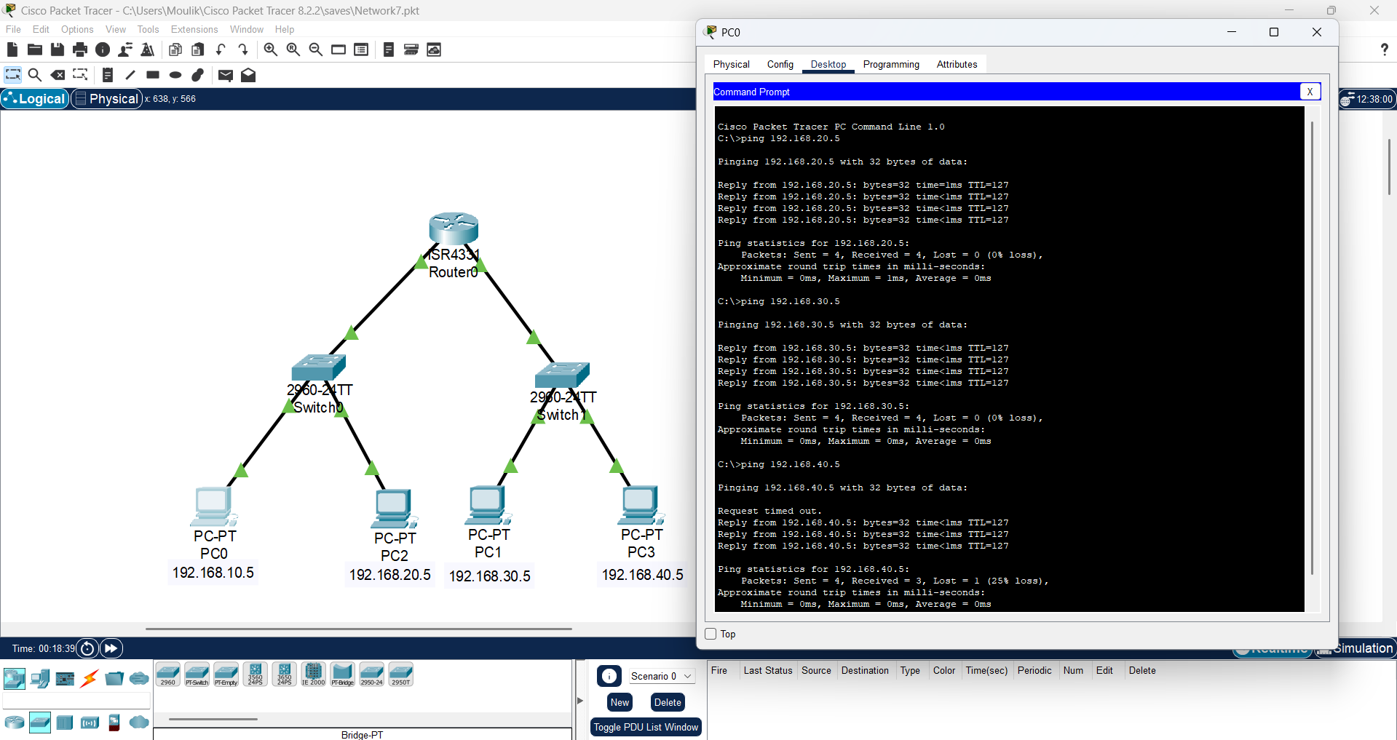

**The case where the ping fails when we assign different IP address to PC2 when it belongs to 192.168.20.1 default gateway.** 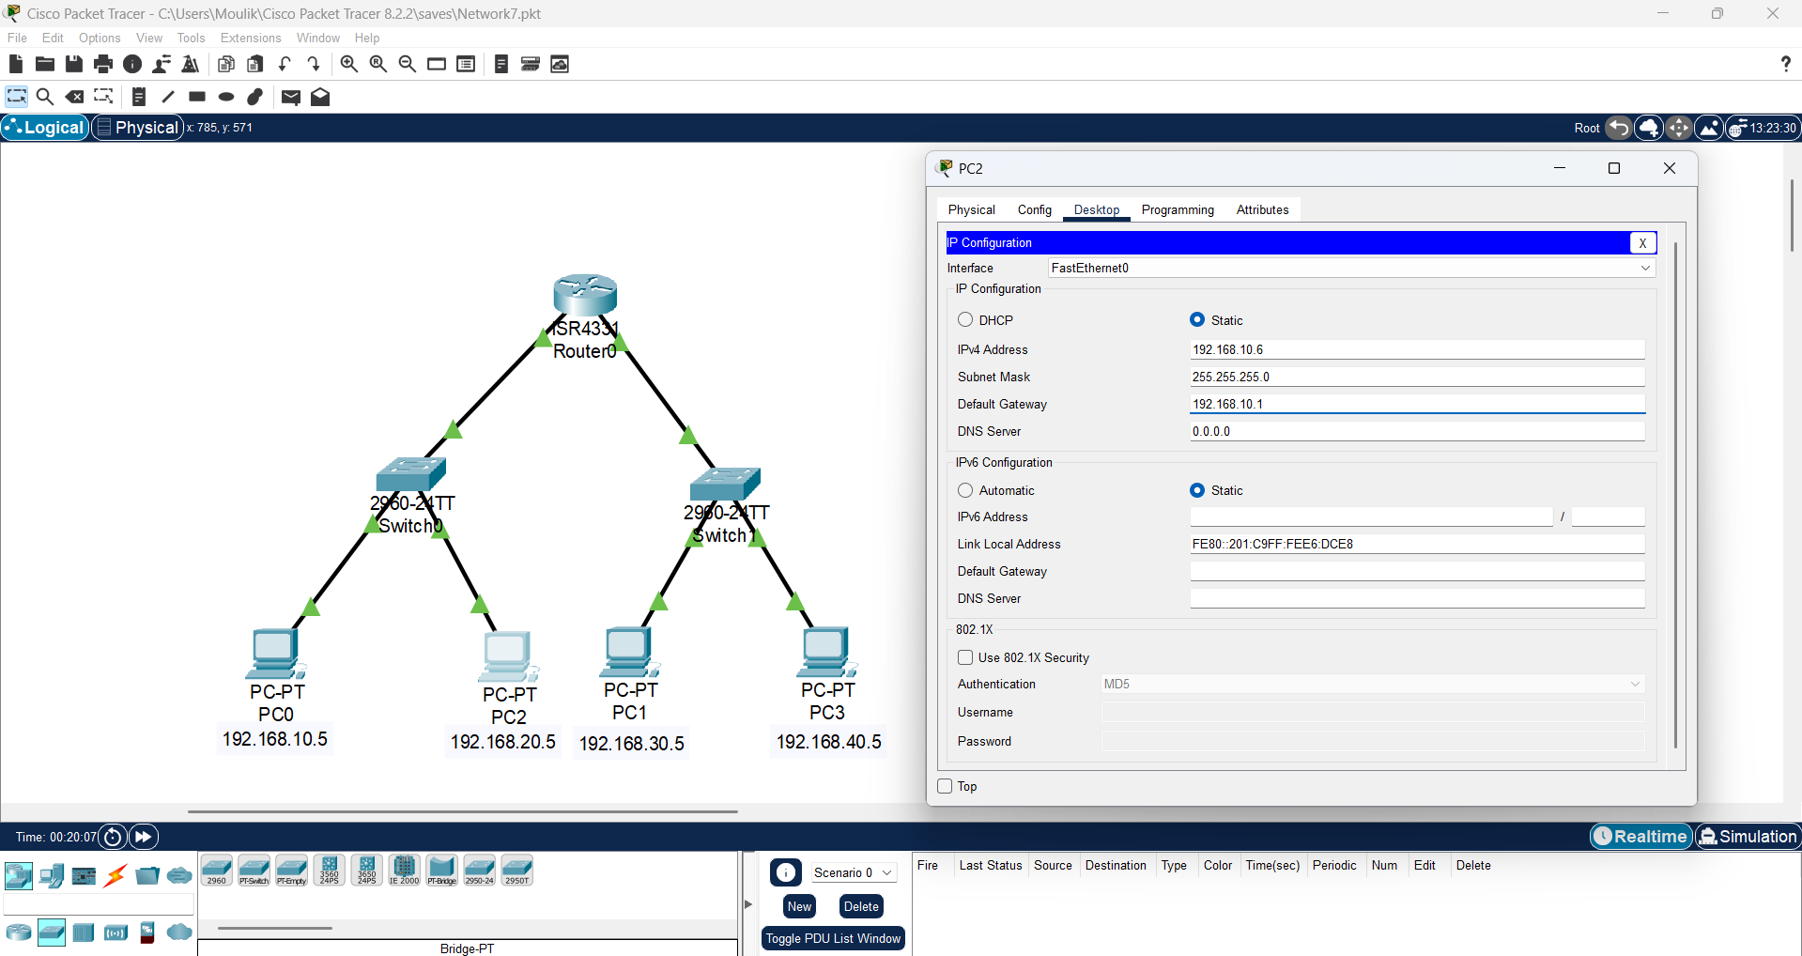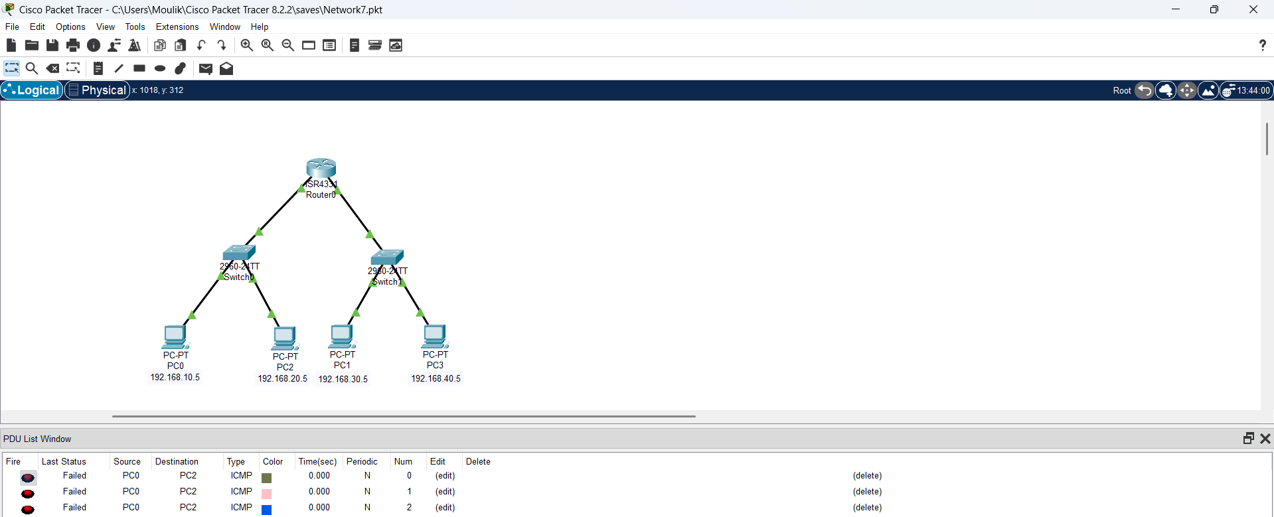

**We failed to ping PC2 from PC0.**

**This is a comment is cisco’s official website, according to the the default gateway that we assign in the end PC wouldn’t effect the ping even if the default gateway is configured wrongly. So the above ping failure is caused purely do the wrong assignment of IP address in relation the the default gateway that we assigned in the router and switch but not due to the wrong assignment of gateway in the end PC.** 